

“¡Para sí, para todos!”

School of Engineering

Cloud Fundamentals

First Term Exam

Ana Cristina Castillo Escobar

**INDEX**

Introduction……………………………………………………………………………………………………….…………………………3

SCRUM………………………………………………………………………………………………………………………….………………4

Version control workflow………………………………………………………………………………..………..………………….6

Support/tracking tickets system……………………………………………………………………………………………………6

**INTRODUCTION**

DevOps is a current culture used by many of the great software development and innovative companies around the world. In this document you will find a brief explanation of some of the phases of this continuous integration process, illustrated with real free-to-use tools that anybody can try out whenever they want.

The phases you will find are Plan (Trello), Build (GitHub, Fork) and Monitor (Freshdesk). The first phase is based on SCRUM, a methodology consisted of short periods of time (sprints) of which a product is obtained when they finish. These cycles can’t last more than three weeks. All this process is controlled through daily, biweekly and monthly SCRUM: meetings where the teams gather to inform how well or wrong the development of the project is going.

In this example, Build Phase is managed with GitHub. Branches, push, pull, and many other new concepts come with this software which saves our lives when it comes to development.

Last but not least, the core of the DevOps ideology is the customer, who always has to have some way to reach the developers and let them know all of his thoughts. For the Monitor Phase, the software engineers count with Freshdesk, to help them track all the conversations with the clients.

Not all of the phases are mentioned in this document, but something we can’t forget to comment is DevOps is all about an endless cycle. Continuous Development. Continuous Integration. Continuous Testing. Continuous Monitoring. Continuous Feedback. Continuous Deployment. Continuous Operations. Continuous Evolve. This is DevOps.

**SCRUM**

The scrum daily meetings will take place every day at 9:00 am. These reunions will be the first activity of the day, they will last 15 minutes and their purpose is reviewing what has already been done, which problems have been found and what actions will be done that day.

At the end of the month, a scrum monthly will be held, so the leaders of each team will show the advanced percentage of the development, comment on the setbacks and justify them to the managers, with not very technical words, so they will be able to understand how the project is going.

The control of activities and roles will be carried out with the help of the software Trello. Its intuitive interface and price (it is for free) makes it a good option for new enterprises attempting to start working.

**Roles**

Mobile app programmers:

* Heyner Fernando Cruz Guzmán
* Jorge Said Serrano Soto

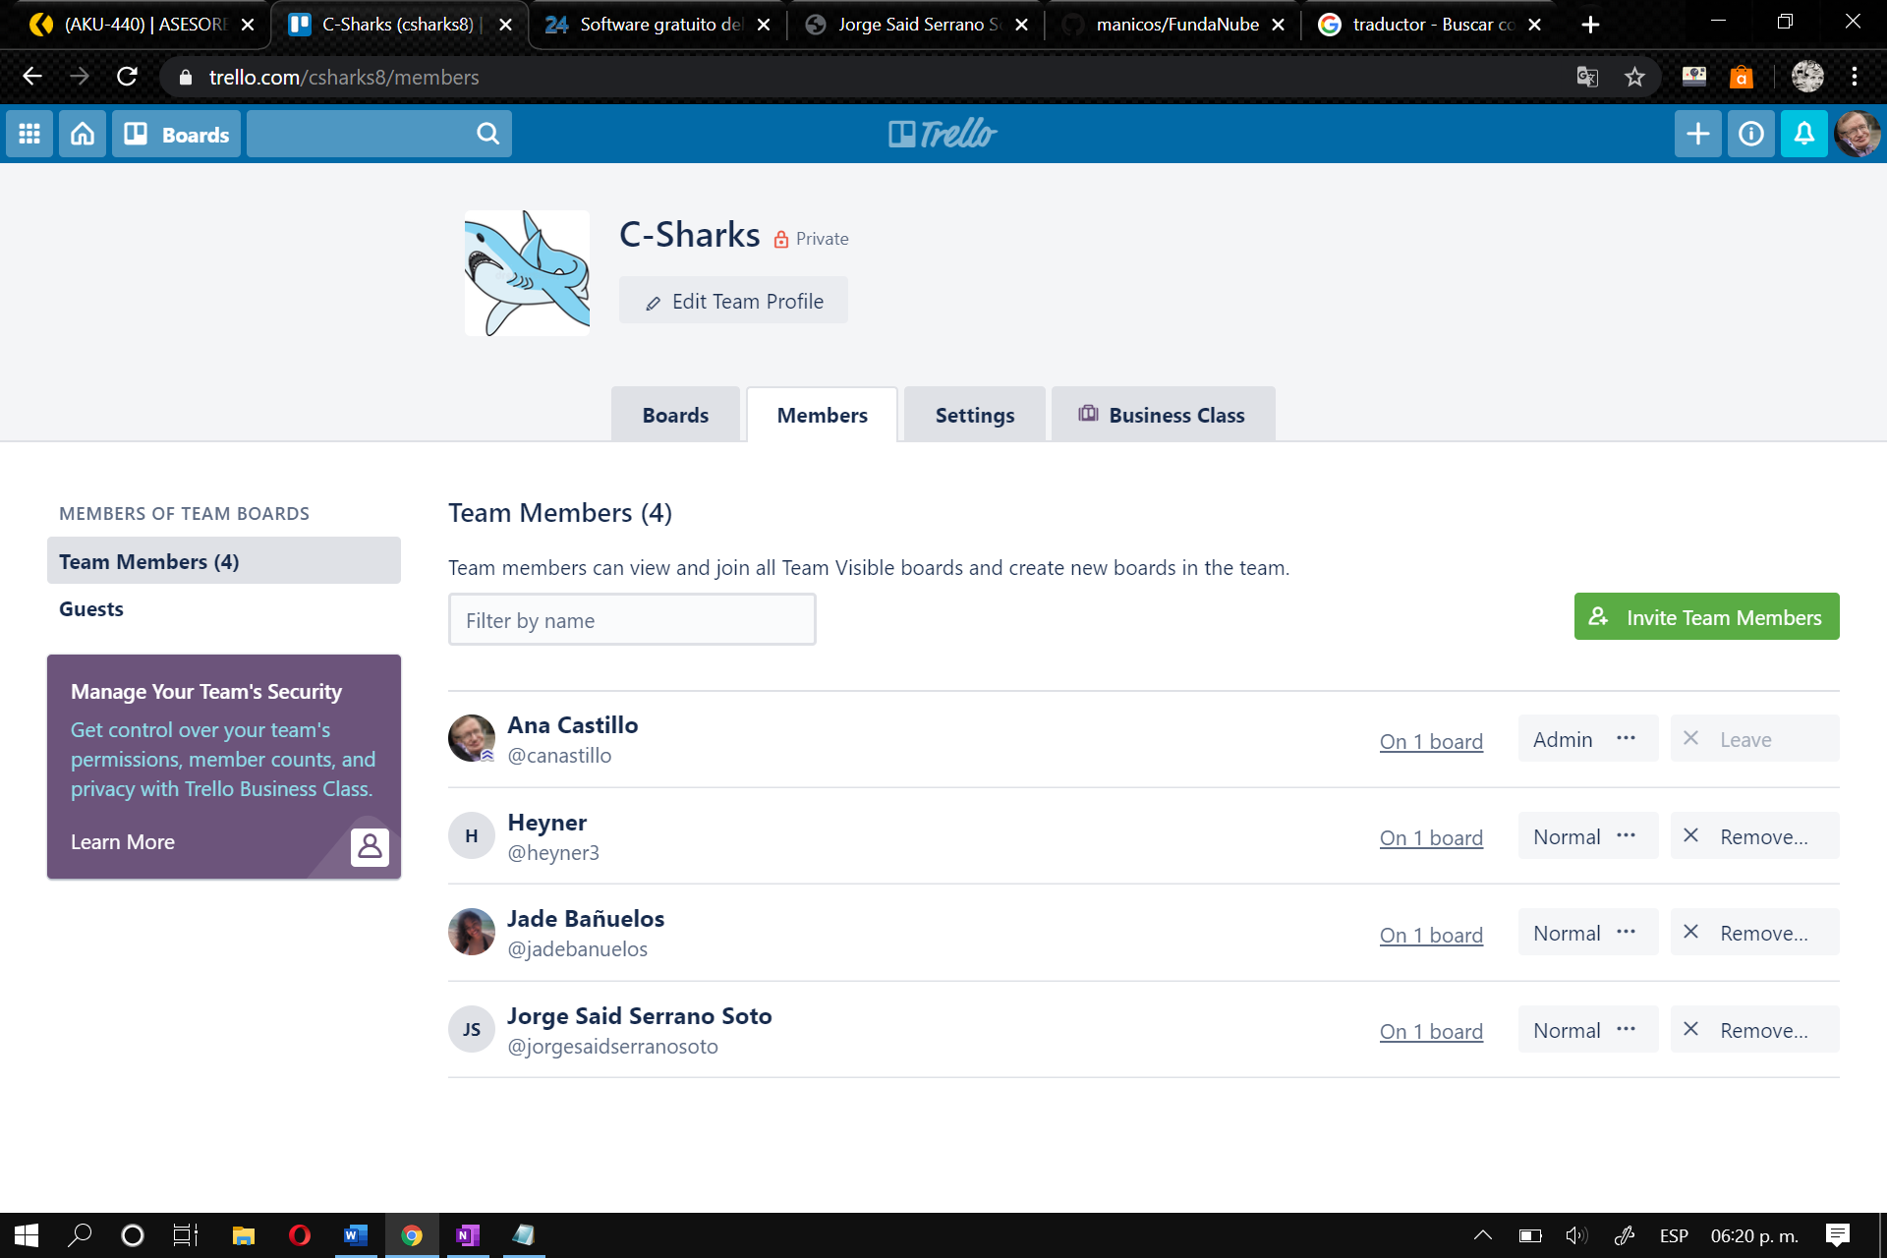Frontend programmers:

* Heyner Fernando Cruz
* Jade Odet Itzel Bañuelos Gómez

Backend programmers:

* Ana Cristina Castillo Escobar
* Jorge Said Serrano Soto

Mobile app UI Designers:

* Heyner Fernando Cruz Guzmán
* Jorge Said Serrano Soto

Website UI Designers:

* Ana Cristina Castillo Escobar
* Jade Odet Itzel Bañuelos Gómez

Database designers:

* Ana Cristina Castillo Escobar Members of the team
* Heyner Fernando Cruz Guzmán

Documentation:

* Ana Cristina Castillo Escobar
* Jade Odet Itzel Bañuelos Gómez
* Heyner Fernando Cruz Guzmán
* Jorge Said Serrano Soto

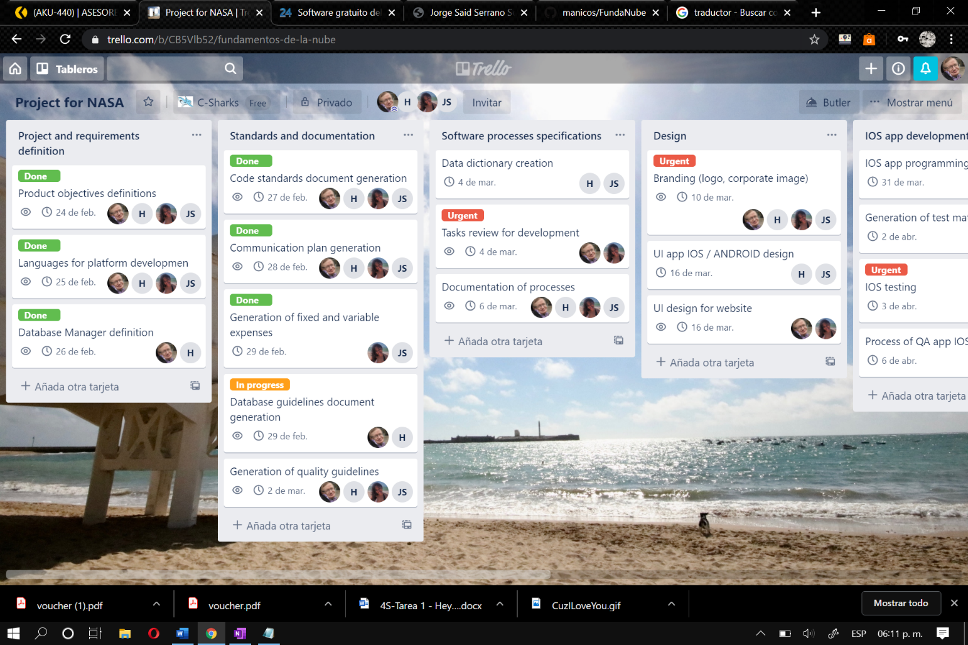**Board on Trello**

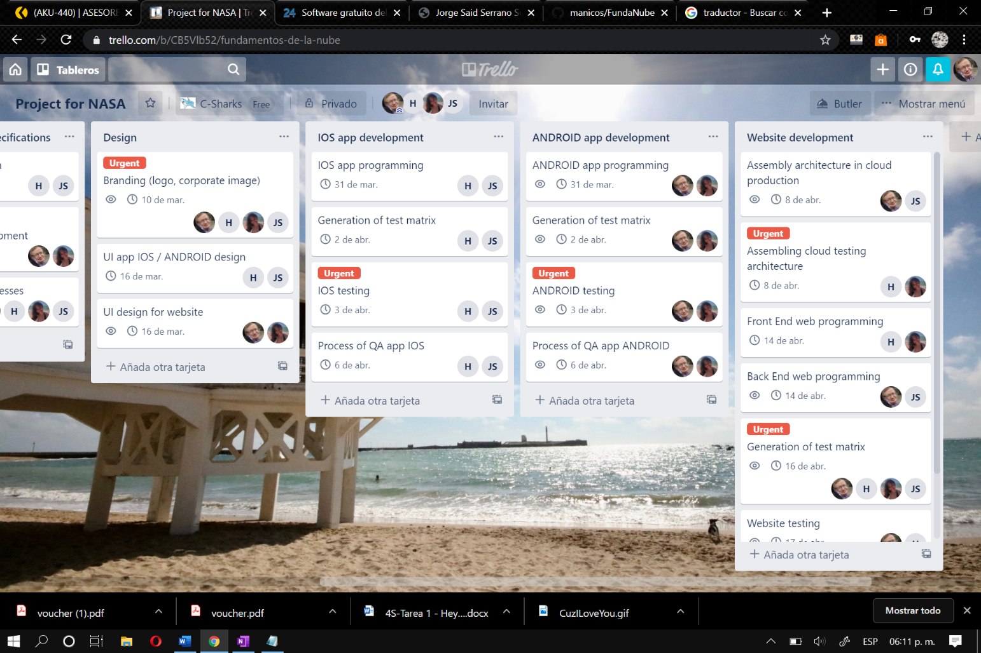

**Version control workflow**

When it comes to programming, a tool is needed so the developers are able to have a real control over the versions and builds of their software. This is when GitHub appears like the hero of the story. Many people can code from different workstations. When you are about to work, you have to *pull* the changes that other people may have done*,* and when your job is finished, you are ready to *push* your changes into the *develop branch* until the software is ready enough to merge it with the *Master branch,* and then a new build is born. Every change in the files is recorded thanks to the *commits,* letting us know who did what.

All of these operations are executed by command lines. To facilitate all this process, we will use Fork, a git client that allows do all GitHub stuff but graphically.

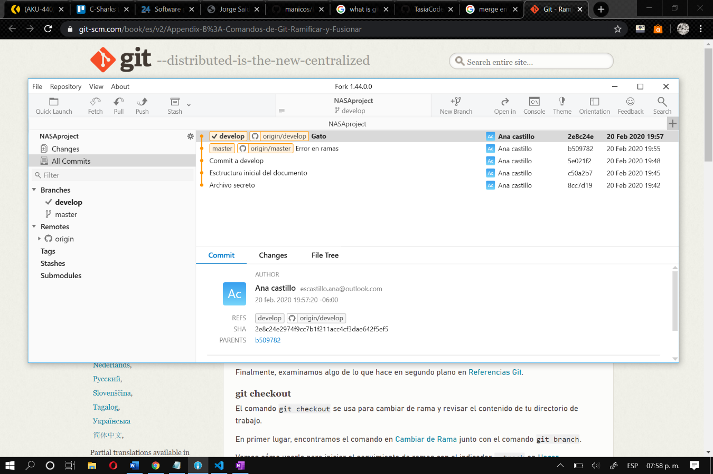

**Support/tracking tickets system**

Once the software has been released, it is of vital importance than the development team gets in the phase of monitoring. This is the part of the DevOps process when the staff dedicates its time to read all the comments, suggestions and complains from the users. All this feedback is useful, because while the support team helps the customers solving their problems, the developers can learn from their mistakes, come up with new ideas, and keep improving their software. It all starts again. This is DevOps.

To fulfill this supporting part, we will use Freshdesk. This is an Omnichannel, AI-driven solution for customer service that will help us keep an eye on all the social networks and other ways the users can contact us by.

Every time a client uses one of these tools (Twitter, Facebook, phone, email) to let us know there was a problem, Freshdesk helps you keep track of the conversations by converting them into tickets. This allows you to prioritize, categorize and assign them to the right people.

